**Android Games Resolution**

* Dimensions in Android

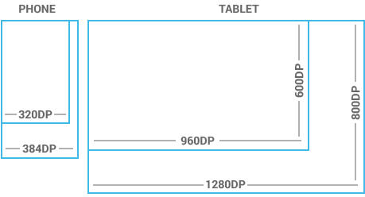

# DPs (for Android)

# The unit of measure in Android is called density-independent pixel. It is almost same as points. It equals roughly 160 pixels fitted into 1 inch of screen space just like iOS’s 163. So, DP is a physical unit of measurement as per the coordinate system held by a computer and is like an abstraction of a pixel for use by an application which is further converted to physical pixels through a supporting system. DP is of major use while working on the Android platform. It is a virtual pixel unit and should be utilized while planning UI layout to define design dimensions or position in a density-independent manner.

# The range of Screens Applicable

Android has categorized actual screen sizes and densities into 4 general sizes- small, normal, large and xlarge. For densities, 6 ranges has been set- idpi (low)~120 dpi; mdpi (medium)~160dpi; hdpi (high)~240 dpi; xhdpi (extra-high)~320 dpi; xxhdpi( extra-extra-high)~480 dpi; xxxhdpi (extra-extra-extra-high)~640 dpi. The generalized sizes and densities revolve around a baseline configuration that comprises of normal size and mdpi (medium) density.

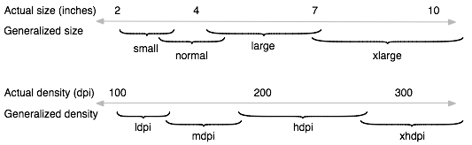

As you undergo designing for different UIs in multiple screens, you will learn that each design needs a minimum amount of space. So, each generalized set requires a minimum resolution that is very well marked by the system. These minimum sizes are also in dp units in order to avoid any trouble while making changes in screen density.

* Xlarge screens are minimum 960dp x 720dp
* Large screens are minimum 640dp x 480dp
* Normal screens are minimum 470dp x 320dp
* Small screens are minimum 426dp x 320dp

# Source : https://think360studio.com/what-dimensions-resolution-should-be-for-ios-and-android-app-design/